Student Feedback on CEIAG Activities

Project Based Learning Weeks for Year 10 Students

These weeks give students the opportunity to work on cross curricular projects linked to specific careers and subject areas. Students often work in groups with a set goal to achieve within a specific timeframe. Projects focus on our specialist subjects of Business, Computing and Creative Media, as well as opportunities in other subject areas. These opportunities include visits to businesses, workshops with businesses at Logic, Work Experience preparation and activities with Universities linked to Post 18 options.

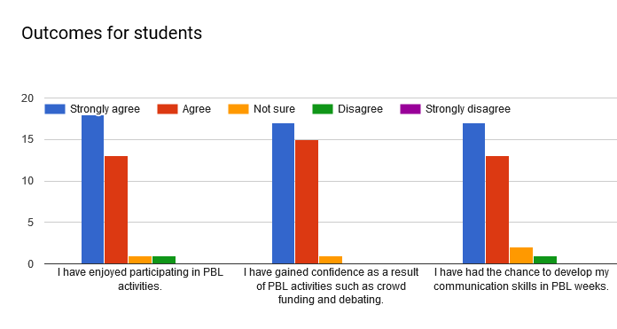
This feedback was specifically from Year 10. As can be seen, the majority of students thought that PBL had been well delivered and they had both enjoyed and gained meaningful outcomes from the exercises.

Project Based Learning Weeks for Year 12 and Year 13 Students

These weeks give students the opportunity to work on cross curricular projects linked to specific careers and subject areas. Projects focus on our specialist subjects of Business, Computing and Creative Media, as well as opportunities in other subject areas. We also used these weeks to deliver part of our CEIAG programme for students, with university visits, apprenticeship presentations and involvement and post 18 transition activities.

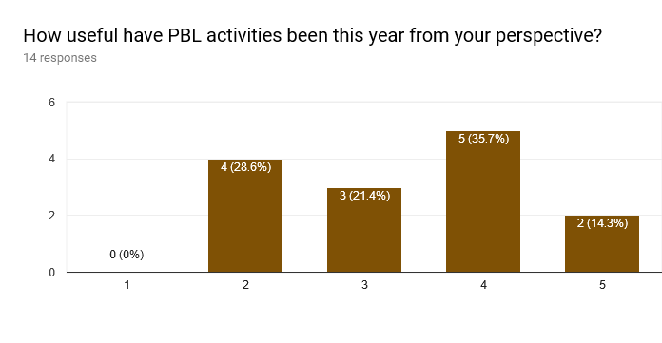
(In this instance, 1 is ‘not at all’ and 5 is ‘very good)

For 2018, we have taken on board student feedback and redesigned our use of PBL weeks at KS5. There will still be projects and activities for students to participate in but our CEIAG work will be more focused and delivered through our Employer Engagement Days each week. This is to avoid duplication and an ‘over exposure’ to post 18 transition.

Year 12 Work Place Preparation Programme (WPPP)

The WPPP provided an opportunity to prepare students for the various pathways and placements they would undertake throughout the year. This included CV workshops, networking skills, finance, apprenticeship provision, resilience training and team building activities. Students were then placed onto pathways to match their career aspirations.

(In these questions, 1 is ‘completely agree’ and 5 is ‘completely disagree)
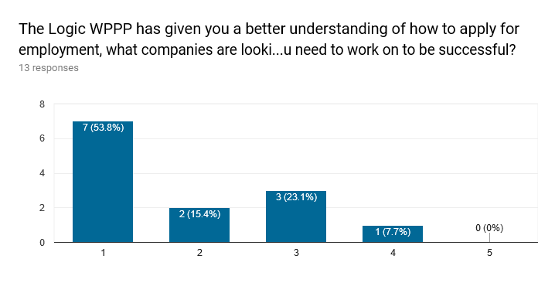
70% of respondents indicated they thought the preparation was valuable in terms of the employee focus with a further 23% sitting in the middle. Only one respondent thought it was not as useful.

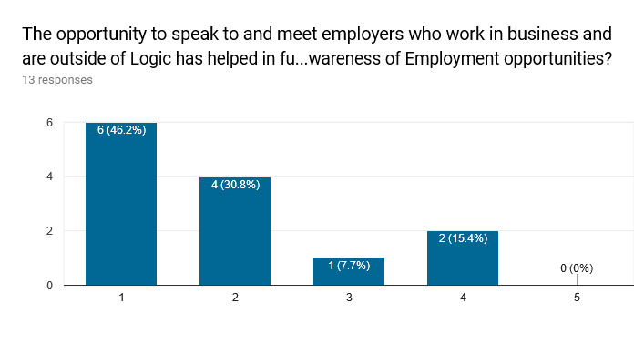
Students had many opportunities throughout the first six weeks to meet with and engage potential employers. This was in the form of interview training or workshops. The majority clearly indicated this was effective and helped them in their understanding of future opportunities.

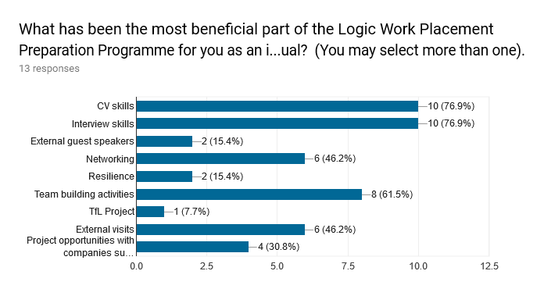
This information is more subjective as many respondents will see benefits in different aspects of the WPPP, however it is clear that the more traditional/core aspects of employee preparation were seen as the most beneficial.

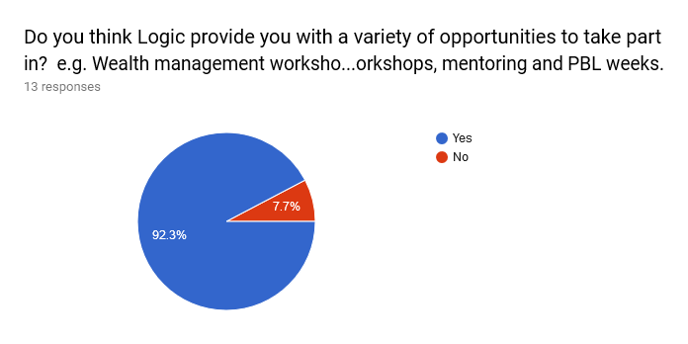
Again, a resoundingly positive response from the value of the activities provided. The 7.7% represents 1 respondent and is thus a technical outlier. While there are things to improve, the overall conclusion is that the WPPP generally did what it offered and was a success.

Year 12 General Employer Engagement Weeks

Students were asked to comment on the wider employer engagement packages that were provided over Wednesdays. These included the Mixed Business pathway, Russell Group, Gaia Computing Network Professional and Accounting Professional pathways. The aim of this was to see what improvements needed to be made and how the students thought the programme delivery had supported them in their respective pathways.

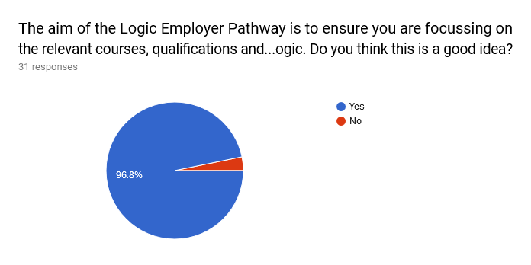
Student feedback on the overall employer pathway model was very positive and the general tone of Employer Engagement weeks was well received.

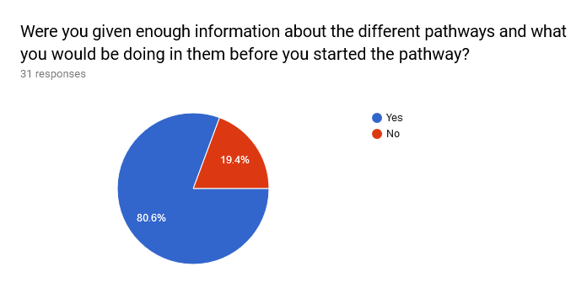
An area for improvement identified is to make the WPPP weeks more focused on providing option advice for students and then getting students to select the pathways they feel will suit them from a personal and professional perspective. Overall feedback was positive but the changes proposed for next year might go some way to meeting the 20% who thought they needed more support in this area. These changes have been made in preparation for 2018-2019.

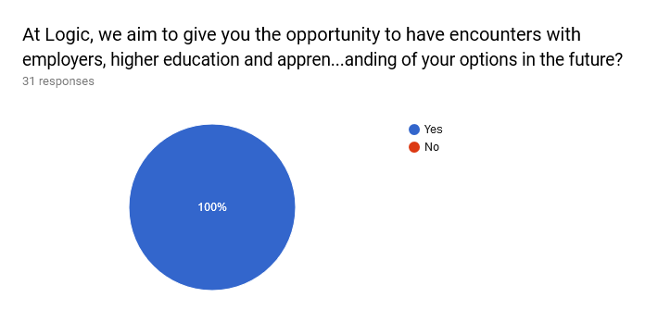
The school prides itself on the relationships it has with outside providers for workshops, advice and work placements. The findings from students also support this as one of the key areas of strength within the school. These relationships will be strengthened next year and beyond. This is also in line with the Gatsby framework and does take time to cultivate. All students have had access to employers during outside speakers, visits and careers fairs and most students have undertaken work placements.

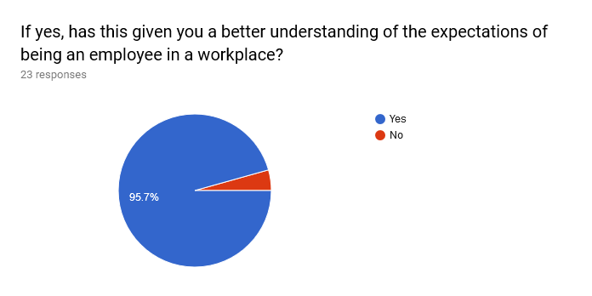
Those students who had undertaken placements from the Mixed, Gaia and Accountancy pathways clearly thought that it had fulfilled the requirement of giving them the perspective of an employee and better preparing them to make balanced choices on their destinations.

Overall, the Wednesday programme has been well received by most of Year 12. Some comments on the number of visits and better targeting of outside speakers has given valuable feedback to enable improvements for next year. This includes an increase in pathways to include Creative Media and more student involvement in their pathway choice.

Summary of Year 12 Work Placement Opportunities.

The total number of students who have undertaken a work placement which has contributed to their course or is linked to their pathway in Year 12 is 64 out of 75 students. This does not include those students who already undertake a part time role outside of Logic.

  - BTEC Business Unit 27 Course where students undertake a minimum placement of one week - 22 students
  - Careers Academy where students undertake a 4-6 week internship during July / August with companies including BP and Citibank - 18 students.
  - Gaia Technologies Computing Pathway where students undertake practical industry sessions and a work placement with Gaia Technologies - 10 students
  - A Social Media Project with an external business or organisation which sees students develop and run social media platforms for businesses - 14 students (plus 10 others on Gaia Pathway already accounted for).

Year 13 Employer Engagement

Having undertaken a significant amount of work placements and employer engagement in Year 12, the focus for Year 13 students naturally shifted to career progression, transition and identifying suitable destinations for their future.
As part of this, all students undertook a 6 week Transition Programme that focused on Post 18 progression. This was run in conjunction with employers, apprenticeship providers, universities and careers advisors, allowing students to identify the rage of opportunities available to them on leaving Logic.

Year 13 students were asked to complete a questionnaire towards the end of Year 13 to review the Employer Engagement activities they had undertaken, with a particular focus on our Wednesday EE programme.

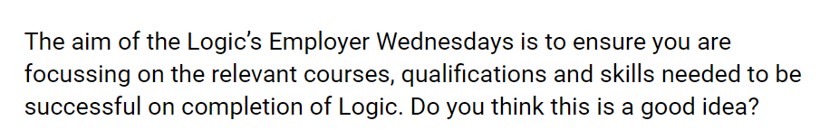
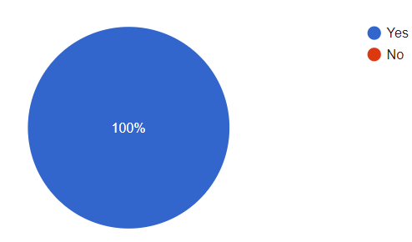

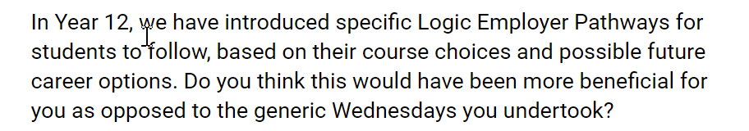

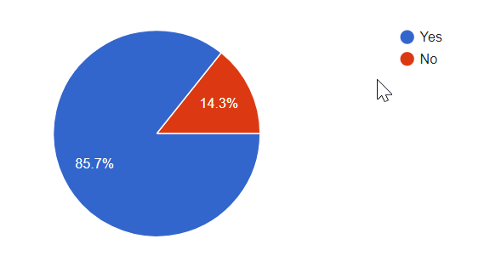

While in Year 12, students undertook an identical and more generic work placement programme throughout the year. For our more recent Year 12, this was adapted and made more industry specific. The feedback from Y13 suggested they would have supported this opportunity for them if it had been available.

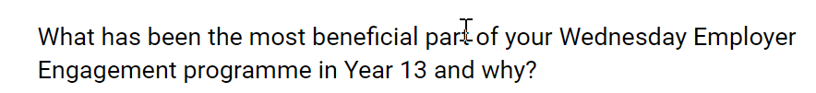

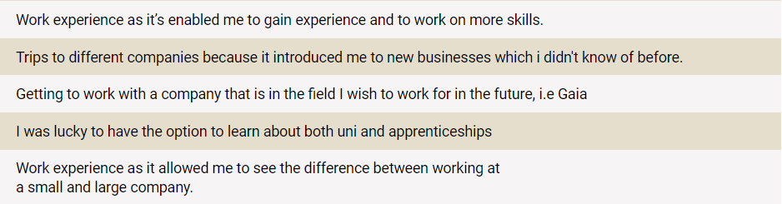

Student feedback supports some of the key opportunities we continue to provide students. This includes work experience opportunities, industry visits and our transition programme. These are now being developed to be more specific and relevant to individual student’s pathways and career fields.

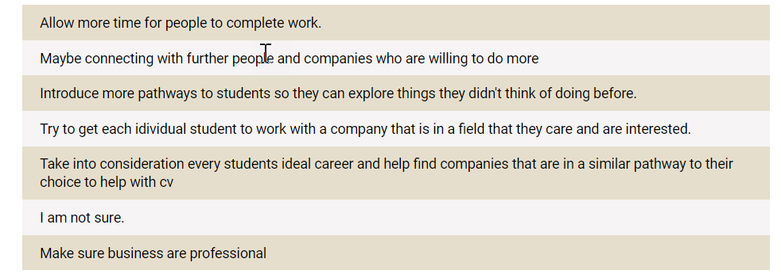

The students feedback reflects some of the changes we are now looking to make moving forward. This includes the extension of our pathways to include Creative Media and the opportunity for students to have more involvement in their pathway choice; more specific employer engagement activities linked to each individual pathway; and more individual development time for students to focus on work and personal projects.

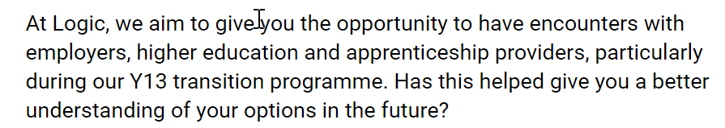

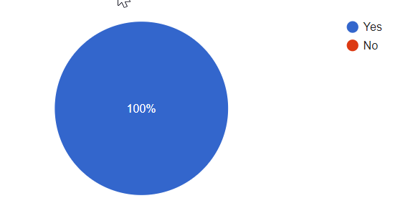
Our Transition programme gave students the opportunity to learn about a wide range of Post 18 options, a vital part of ensuring effective and impartial CEIAG for all students, in line with the Gatsby framework.

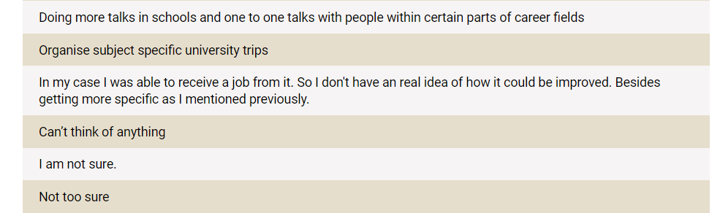

The responses again reflect the need to personalise our programme to ensure students are engaged in relevant opportunities linked to their future, as highlighted in our future planning. We have now redesigned our Transition programme to take account of student plans, with a particular focus on student awareness of apprenticeship applications and the process involved.

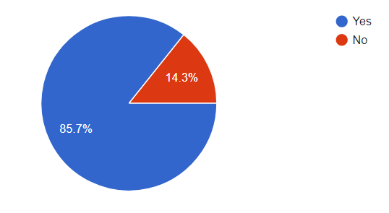
Overall, students have been positive about the Logic EE programme and its benefit to them. However, it is clear we need to ensure students are engaged in specific activities linked to their pathways; and are given further advice and guidance when looking at Post 18 options relevant to them.

