Person(s) Responsible: PRINCIPAL | Principal: JAY LOCKWOOD
Date Approved: 9 October 2018 | .
Date of Review: ANNUALLY

Vision and Ethos.

Our ethos for our students is simple – “Looking forwards, Looking outwards and Taking action”. Logic Studio School has been developed to link the education that students receive with the careers available in the local economy and beyond. We want to harvest genuine knowledge, understanding and wisdom and acknowledge that a diet of exam-based content is not healthy for our pupils. We understand how changes to technology will transform the nature of employment and are passionate about developing digital skills in our community. Jobs of the future will require far more creativity, imagination, problem-solving, teamwork, empathy, entrepreneurship and similar skills that can and must all be taught now. We focus on outstanding progression routes into university, employment or further training, with a rigorous but industry relevant curriculum, connections with our employer partners and a small school approach.

When students leave Logic they will have the skills needed for the modern economy and tomorrow’s job market:
- All the basic skills that employers say students are lacking – digital literacy, being able to write well and able to apply maths to real life.
- The character skills of confidence and resilience – able to learn from mistakes in preparation to succeed.
- Communication skills – to listen what’s happening around, make themselves heard, understood and respected.
Year 10 and 11 – GCSE
Year 10 and 11 students study a broad but academically rigorous curriculum. In addition to our specialist areas, nearly all students study English, Maths, Science and Modern Foreign Languages or at least one Humanity; these are not only vital subjects for securing a place in Higher Education but also for being highly functional within our global society. Additional subjects depend upon the pathway on which the student has been placed. P.E. is taught to all students with an increased emphasis on developing sporting interests that students will continue with after leaving us.
In Years 10 and 11, students are generally set by ability, albeit in very small year groups. Again, there is a strong emphasis on teacher-led differentiation and targeted intervention lessons for any student not be progressing as they should.
Outside of class, students complete PREP in all examined subjects at Key Stage 4. There is an increased expectation that students spend more time on this work at outside of school as the quantity of work given will exceed the time allocated during timetabled PREP sessions. It is important that students form this habit in order to support the development of their study skills in preparation for external examinations. PREP tasks can take many different forms: consolidating classwork through further or extended questions, ‘interleaving’ tasks which ask the students to recall work covered a few weeks ago, ‘flipped learning’ tasks which prime the students with information ready for future teaching, the development of revision notes and study aids that summarise key topic areas or any other appropriate task the teacher sees fit.
It is important that students are assessed regularly so that they are given the opportunity to apply their class-based understanding to the types of questions they will receive in external examinations. We believe that everybody benefits from this. The student has an opportunity to prepare for and experience the same type of questions they will see in their final examinations and it highlights – for both the student and the teacher – areas of strength and weakness so that teaching may be adapted to better meet the learner’s needs. It also provides the school with an opportunity to identify those groups not performing in line with expectations so that school-wide intervention may be put into place. In addition to in-class assessment there are also three periods of mock examinations. These take place in the June of Year 10 and the December and March of Year 11. At this point students experience the pressure of preparing for and sitting multiple exams in a short space of time.
Through incisive monitoring of assessment data the school carefully creates intervention groups. We first focus on the ‘basics’ (students not achieving good progression in English and/or Mathematics), then widen this to include Science, Modern Foreign Languages and Humanities. We also look carefully at the performance of key sub-groups within the school, for example White British, Pupil Premium, Most Able, etc. Senior leaders hold regular meetings to discuss the progress of these students and teachers are required to indicate the Wave 1 interventions that have been put in place to support these students, as per class context sheets after data gathering periods.
Attendance is also monitored closely with separate intervention in place where we recognise this is impacting on learning. Some students may be timetabled for specific intervention lessons in English, Mathematics and Science during Year 11. We also look at how periods of PREP can be used differently to further support the progression of these students.

Key Stage 4 - Subject Overview
Subject | Qualification and Board | Description
English | GCSE/ AQA | All students will study both GCSE English and English Literature.
Maths | GCSE/ Edexcel | All students will study GCSE Mathematics.
Science | GCSE/ Edxecel | At Key Stage 4 all students are able to study Chemistry.
Science | GCSE/ Edexcel | At Key Stage 4 all students are able to study Computer Science.
Business | BTEC / Pearson | All students study Business BTEC,
Humanities | GCSE/ Edexcel B | At Key Stage 4 all students are able to study Geography and/or History.
MFL | GCSE/ WJEC | At Key Stage 4 students will have the optional study of Spanish.
Creative Media | BTEC/ Pearson | All students study the Creative Media BTEC,
P.E | N/A | All students will have at least one compulsory enrichment session which is focused on activity and movement.

PREP – “Proactively Revise, Recap and Prepare” – KS4

Rationale:
With the new GCSEs coming into force the demands are huge on our students and teachers. Not only do our students need to have a far greater breadth of knowledge but they will also have to learn the discipline of working more independently and doing work outside of taught lesson time. PREP occurs every morning from 8.50- 9.40 am in smaller ‘family’ size groups. It is expected that many of the PREP tasks given support ‘flipped learning’, allowing students to prepare for their next lesson building greater opportunities for strong progress.
Key Stage 4
- Each PREP group will have a labelled PREP box in the Teaching and Learning Room. It is the responsibility of the subject teacher to ensure PREP is ready in these boxes by 8:40am every morning, ready for the PREP Tutor to take their rooms. Boxes will be labelled with the PREP Tutor’s initials and Prep Room.
- Students should be given clear instructions on how to complete their work. PREP tasks should be focused around reducing and recalling information.
- In a lesson following PREP, subject teachers are required to review or test what students have learnt or completed: to reapply information or recall key words and/or definitions, for example.
- All work should be completed in PREP time and handed in to the PREP tutor to take back to the Teaching and Learning Room.
- Year 10 Prep should be well-structured, following the ALL / MOST / SOME format. This is to ensure that all students are working at the correct level and that they do not run out of things to do.
- If the work you have set for ALL students has not been completed, then a detention should be issued. Likewise, subject teachers should be clear about what they expect individuals to be able to achieve in PREP time. We need to stretch our most able.
- Students should work in silence. No laptops allowed.
PSHE and Religious Education
The personal development and wellbeing of students always features as part of our key priorities. We believe that this is the bedrock of good mental and physical health. Consequently students can engage with their academic learning better. PHSE and R.E. is currently delivered through two strands: ‘PBL weeks’ and our PSHE programme. ‘PBL weeks’ include numerous opportunities, from participation in debates, partaking in the democratic process, workshops, visits and keynote speakers and a range of activities around well-being, keeping safe, sex and relationships. These are reinforced by a weekly PSHE lesson at KS4 which is reflects the needs and interests of our students and is planned to ensure purposeful and relevant use of time. Our weekly assembly programme provides a series of rich, diverse and well-coordinated assemblies. Many members of staff lead on Whole Academy assemblies. R.E. is also taught implicitly in many subject areas across KS4.

Year 12 and 13 – Level 3
Our Tudor Park Trust curriculum offer at Key Stage 5 is supported by Logic Studio School, Springwest Academy and our external partner school – Reach Academy. This allows us to run a broad range of viable classes. Specific subject offerings do vary from year to year depending primarily on where we feel we have ‘subject excellence’ and the requirements of our students.
The majority of students study three courses for the duration of their two year programme of study. Through careful transition work students may opt to ‘try’ subjects for a short period at the beginning of Year 12. We also hold ‘entry assessments’ in the first three weeks of our courses to ensure that students are placed on suitable courses. There are a number of different pathways that students can select from to suit their academic ability.
Students sit interim assessments at 6 points throughout the year. These are designed to support students in preparing for terminal examinations by regularly requiring students to collate their notes and test their knowledge. Data from these assessments are used to create RAP groups which are shared with staff. In class intervention and high quality differentiation are key to ensuring that learners needs are met. Students underachieving across two or three subjects are assigned to additional study groups for further support.
Where students do not have timetabled lessons they have timetabled and supervised private study. This is to support the increase in independent work that is expected from students; for each hour of direct teaching the student receives they should be dedicating an hour of their time outside of class to consolidate and extend their understanding.
Further pastoral support, including CEIAG is delivered by Logic Studio School.

Pathway overview:

Typical grades | Mainly 7s and 8s at GCSE | Mostly 5’s with a couple of 6’s at GCSEs | At least x5 4’s at CGSE
Typical courses | 3 A-Levels, which are now all taken at the end of Year 13. An additional EPQ (see course handbook) might be taken to support you area of interest, Universities love this qualification. | You might do one or two A-levels and one or two specialist BTECs. For example, Economics and Digital Games Design. Lots of different combinations can be taken, with 3 the ideal number. | You will mainly do BTEC Level 3 qualifications. We might need to retake a Maths or English retake but hopefully not.
The TPET Extras | - EPQ support and tutoring  - University mentoring scheme  - UCAS programme  - Critical thinking coaching  - Foreign residential built around your A-Level courses  - Small class sizes | - 6 weeks of work placements per year  - Employer engagement programme every Wednesday  - Personal Coach and employer mentor  - CV and interview masterclasses  - UCAS programme  - Small class sizes | - 6 weeks of work placements per year  - Employer engagement programme every Wednesday  - Personal Coach and employer mentor  - CV and interview masterclasses  - Apprenticeship application support  - Small class sizes
Destinations | Most likely your destination will be university. In recent years students have progressed to all Russell group universities and even Harvard in America! | You might chose university or you might choose to go straight into employment, either with one of Logic’s employer partners or elsewhere. You will certainly be employable. | University is still an option. However, you might chose to go straight into employment or even start an apprenticeship. You will have gained confidence and skills to make the choice.
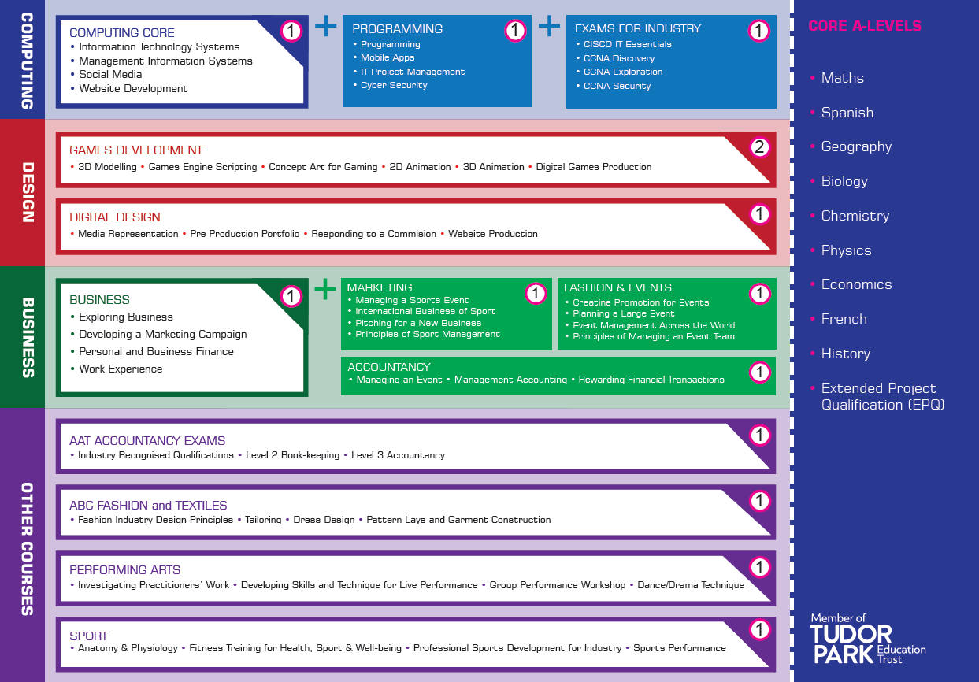

Elective system – For all Year 10-11 and Year 12-13
Students will access sports facilities and extend themselves beyond the curriculum on Tuesdays and Thursday in our elective system. Students can choose from a range of additional courses and workshops (Coding, Language Classes) to improve the ‘whole student’.
Project Based Learning
PBL is a key feature of LSS’s curriculum delivery. In addition to interdisciplinary PBL, “PBL Celebration Weeks” will see normal timetables suspended and larger projects delivered. Each “PBL Celebration Week” will have a theme on which all subjects will be expected to base their curriculum for that week. In these weeks students will work with our business partners on commercial assignments developing competencies expected in the workplace. For more information please see the PBL schedule.

Employer engagement supporting the curriculum at Logic Studio School

Our business partners are keen to support LSS, to grow new talent and to shape their future workforce. Crucially, students will spend a significant portion of their time in real work which goes far beyond work related learning or work experience offered by schools in the area.

- At KS4 this is delivered through PBL weeks.
- At Post-16 every Wednesday is ‘Employer Engagement Day’. No lessons take place in the morning and students take part in a wide range of career ready activities, ranging from taster days to longer periods of work placements and industry accredited exams. For more details see Employer Engagement programme.

Intervention - Curriculum Access and Inclusion

It is the responsibility of all teachers to ‘adapt teaching to respond to the strengths and needs of all pupils’. Our approach to the curriculum and to achievement is that all students are potentially able to master the foundations needed for successful attainment at GCSE and at Level 3. This means that we expect that all students will complete a broad range of GCSE and Level 3 qualifications. We believe that having such high expectations for all is a necessary basis for strong achievement.
We are committed to offering an inclusive curriculum to ensure the best possible progress for all of our students whatever their needs or abilities. This approach seeks to educate students with SEN and EAL within the classroom alongside their peers wherever possible. We aim to make reasonable adjustments to meet the needs of all students. This may include adapting the curriculum slightly and offering some support outside of the mainstream classroom. However, this is done on an individual basis in order to overcome barriers to learning so that the whole curriculum can be accessed. Most support at Logic Studio School will be provided through deployment of Personal Coaches. Students also have extra lessons on their timetable which are used to proactively intervene using either in year assessment or identifying groups who are at risk of underachieving.
Teaching staff will also use a range of inclusive strategies to promote access to the curriculum and Learning Coaches are specifically charged to ensure that teaching is appropriately differentiated. Specific curricular provision is made for some students in the form of a literacy support group in Year 10 and 11. 1:1 maths tuition can be accessed by students with difficulties in this area.

For more information please see the KS4 and KS5 intervention schedules.

Personal Coaching:
For students the Personal Coach is at the heart of their experience at Logic. Personal Coaches will be responsible for helping gain the knowledge and skills needed to participate fully, both in life at school, and life after school. Subject teachers will keep Personal Coaches abreast of each individual's effort and attainment both formally through the reporting system and informally through regular conversations. The Personal Coaches’ role will vary according to the year group, but all are responsible for managing the overall development of their students. Their role will help every student to:
- make the most of their time at LSS
- develop through the delivery of the School’s PSHE syllabus
- achieve a healthy balance between academic, employment and enrichment opportunities
- set targets and organize their study time effectively
- manage university and other applications
- discuss the regular academic assessments and termly reports
Personal Coaches are also expected to find time to listen and talk to students on a regular basis; this may be at work or in class, on the sports field or in lunch.
Furthermore Personal Coaches will assist students in linking together all aspects of life, including their work programmes, to ensure that their time at LSS is optimised and that they exceed expectations, reaching their goals.
Students with English as an additional language
Over 120 community languages are spoken in Hounslow. It has the second highest Indian population in the UK. 46% of the population identify themselves as of Black And Minority Ethnic heritage (JSNA 2012 – 13). The population is fluid due to both domestic and international migration. 71.3% of people living in Hounslow speak English. The other top languages spoken are 4.8% Panjabi, 4.1% Polish, 2.1% Urdu, 1.6% Gujarati, 1.3% Hindi, 1.0% Arabic, 1.0% Somali, 0.9% Nepalese, 0.9% Persian/Farsi. (Census 2011).
We are therefore planning our support at a number of levels.
1) Some additional support needed with literacy
Where additional literacy support is required we will ensure not only that subject teachers are aware of a students’ needs in this area but that additional support is able to be provided both within a classroom or small group targeted setting as appropriate. We will run additional subject specific language classes to enable students to learn the vocabulary associated with a particular course module or curriculum theme.
2) Students arriving into the UK with no prior English
Our general approach will be to enable all students to participate in the main timetable of the school as immersion in English is the surest way in which to learn it quickly. However, we will provide the same class based and small group support as needed, in conjunction with a Trust provision.
A student arriving at the school will be allocated a “buddy”. The buddy’s role will initially be to mentor the new student and ensure that they are able to locate lessons, social activities, understand school rules and expectations but may also include introductions to friends that extend outside of school also. Students will have the opportunity to take accredited courses including GCSEs in their community language. A number of students arriving directly into the school may have come to the UK as asylum seekers to escape conflict or imprisonment within their own country. The family may have experienced high levels of trauma. We will ensure that support is provided from within our pastoral system and through referral for external agency support if required.
3) Students with EAL and additional learning needs
We will identity any students who may have additional learning needs or a special educational need through our baseline and formative assessment process. A process of assessment and support will be put into place by the school SENDCO. Business literacy and numeracy has been identified as a skill gap in the young people our business partners seek to employ. Rooting literacy and numeracy in a work based context is key to both our educational plan. LSS will also use Personal Coaches to give additional support to students with weak literacy.

Improving outcomes for students with special educational needs (SEN) and learning difficulties and/or a disability (LDD)
Students with SEN will be identified on entry and an individual support plan instigated. The SENCO will ensure that all staff are aware of specific need and be responsible for monitoring the progress of students with statements. LSS will ensure that all students with SEN will have access to the full mainstream curriculum, however at times individuals may be withdrawn for short periods to work on a specific identified area of need

We will also comply with the requirements of the Equality Act 2010 with regard to students with a disability and the Hounslow Fair Access Protocol. The definition of a special educational need is outlined in the Children and Families Act 2014 and states “Children have special educational needs if they have a learning difficulty, which calls for special educational provision to be made for them. “Children have a learning difficulty if they:
a) have significantly greater difficulty in learning than the majority of children of the same age
b) have a disability which prevents or hinders them from making use of educational facilities of a kind generally provided for children of the same age in schools in the area
c) are under compulsory school age and fall within the definition at (a) or (b) above or would so do if special educational provision was not made for them
In addition to the approaches described above we will have in place a clear system of support that enables us to closely identify, monitor, review and track the progress of our students who are experiencing particular difficulties in school. In doing this we will have due regard to the definition above and follow a graduated process of identification and assessment (assess, plan, do, review outcomes) as outlined in the SEND Code of Practice (2014). Please see the SEN policy for more detail.

DIFFERENTIATION
Logic Studio School recognises that differentiation occurs at both curriculum and classroom level. It is Logic Studio School’s responsibility to create a curriculum which enables students to achieve their full potential, one which shows an understanding of their different needs and abilities/talents e.g. applied or academic. Within the classroom the needs of the individual should be reflected in work schemes and lesson plans. Differentiation permeates everything a good teacher does. All teachers therefore need a clear understanding of:
• the ways students learn; students’ current and target levels;
• the ways data can be used to structure learning and enable students to progress;
• specific information about individual students, e.g. IEPs.
• the role and expertise of Personal Coaches or other support available.

CEIAG

We have a duty to secure independent careers guidance for all students. Careers guidance for young people should inspire and motivate them to fulfil their potential. We strive to help every pupil develop high aspirations and consider a broad and ambitious range of careers. We acknowledge that one of the best ways to inspire every pupil is through the creation of real-life contacts with the world of work to help them better understand where different choices can take them in the future. More detail can be found in the CEIAG strategy.
NUMERACY
Logic Studio School believes that good numeracy skills are essential for students to achieve their potential and to function effectively as adults and in the world of work. Students should be able to apply their skills both inside and outside School. Numeracy, therefore, needs to be supported across the whole of the curriculum.
LITERACY

Logic Studio School believes that all students need good literacy skills in order to realise their academic potential and become effective communicators in the outside world. We support a cross-curricular, multi-strategy approach to literacy teaching that is aimed to meet the needs of students of all abilities. Literacy underpins the curriculum by developing students’ abilities to speak, listen, read and write for a wide variety of purposes. Literacy is supported across the whole of the curriculum.

EQUAL OPPORTUNITIES
All work carried out in the school seeks to comply fully Logic Studio School’s Equal Opportunities Policy, in particular:
- That all students should have equal access to learning opportunities, activities, resources and experiences regardless of race, language, religion, culture, disability, gender, sexual orientation or class.
- That resources, activities, opportunities and experiences should reflect all the above, avoid stereotyping of any group and as much as possible.

POLICY REVIEW

This policy will be reviewed annually as part of Logic Studio School Review process.

