Name: Adelle Desouza
Role: Founder
Company: Hire Higher

How have you and your company worked with Logic?

From interactive workshops to talks and careers fairs, our sole aim as an organisation is to increase awareness of all options for young people after the classroom. With experience and a network made up of recent graduates, apprentices and school leavers - we are here to revolutionise careers advice for young people!

Why do you believe that working with Logic and it’s students is important?

Working with students at Logic is really inspiring, whilst they may start quiet and shy - they have huge ambitions and if we can help their awareness on the pathways available to them - well, then that says it all really!

What has been your favourite activity?

Our workshop on gap years! We always have a plan & presentation when it comes to our sessions with Logic students - however they really are creative and have inquiring minds. It's really important that our sessions add value for the students in attendance and sometimes that can become Q&A for those queries they just have nowhere else to go for.

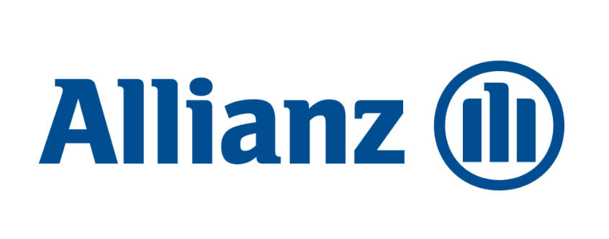

Name: Leila Mehdizadeh
Role: Team Leader
Company: Allianz

How have you and your company worked with Logic?

We have worked with Logic by giving opportunities for work experience and industry visits; providing staff for employer events including speed networking, CV workshops, mock interviews and business insight sessions.

Why do you believe that working with Logic and its students is important?

Because Logic and its teachers are so invested in giving their students every possible opportunity to widen their confidence, ability, knowledge and professional skills which truly aligns with what we want to try and achieve. I have never seen a school so committed to their students and it truly warms my heart to be able to work closely with a school that has such a positive impact on young student’s lives.

What has been your favourite activity?

Whilst we have enjoyed every activity that we have participated in, our favourite so far has been the Industry day. We had the chance to see a group of hardworking and positive students come in without any knowledge on the Insurance industry, and without any real interest in wanting to work in Insurance, come and spend a few hours with us and leave wanting to explore the chance to work for a company like ours further. Knowing what a positive impact Allianz has had on my career, this leaves me with a lot of faith for how it may have the chance to do the same for them.

Name: Masudur Rahman
Role: Community Affairs Manager
Company: BP

How have you and your company worked with Logic?

BP has supported Logic for a number of years through supporting workshops at the school and with their Career Ready programme. Through the support of the Career Ready programme, BP has provided students with a business mentor and offered summer internships across various departments in their Sunbury office.

Why do you believe that working with Logic and it’s students is important?

Working with Logic is important as part of our commitment to promoting opportunities in STEM and helping young student build some of the softer skills they will need in employment. As the school is a local, it is a great opportunity to connect our employees with local students to help broaden their career perspective and access to positive role models.

What has been your favourite activity?

My favourite activity is our Career Ready internships programme where we have supported over a 100 students from the school in taking part in a 6 week paid internship as part of the Career Ready programme. It is wonderful to see the student’s development in the time that they are here, building their confident, presentation and organisational skills. It is heart-warming to listen to their final presentations which is always a tear jerker for the audience.

